**Name** : Ahmed Mahmoud Mohammed Goda Ibrahim

**Date** : 5/6/2021

**B.N**: 21

**Group** : 1

**Section** : 6

**Topic** : Artificial Intelligence

Application brief :

I choose this topic because Artificial intelligence (A.I) is a branch of computer science which deals with the intelligence of the machines commonly associated with intelligent beings.

A.I is used in our daily life such as in healthcare , businesses And in the educational system.

It will benefit every human in the future as it will be used in problem solving and it will reduce hazards as it will preform the dangerous tasks , it will also increase the rate of production in the industrial world because it increase the speed of the process and decrease the rate of errors.

Artificial intelligence has many pros but also has its cons like people losing there jobs to machines and it will be expensive and it will decrease creativity and that is why I chose this topic

Screen shots :

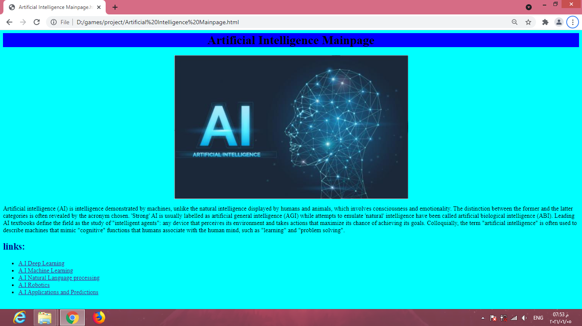1- Mainpage

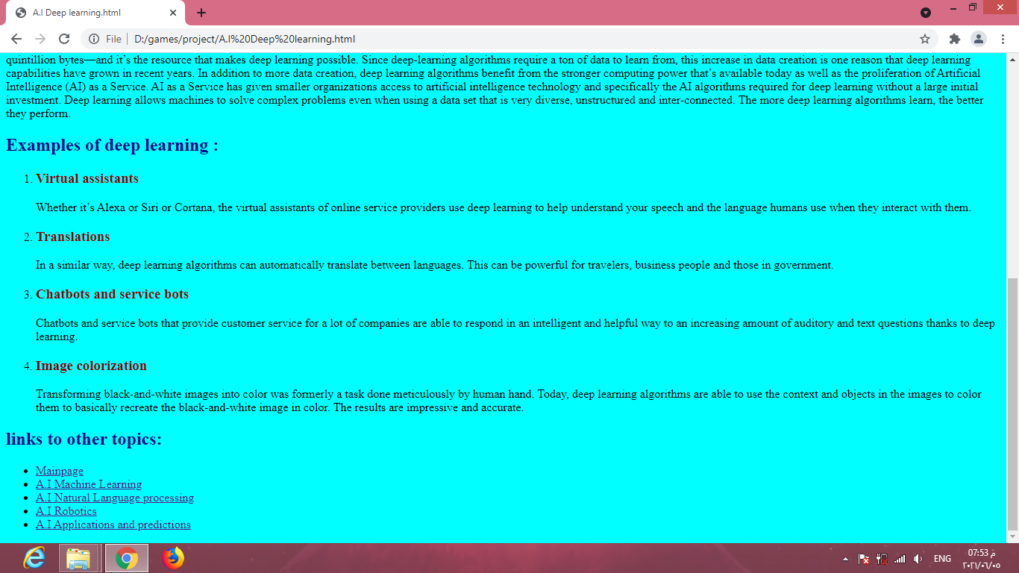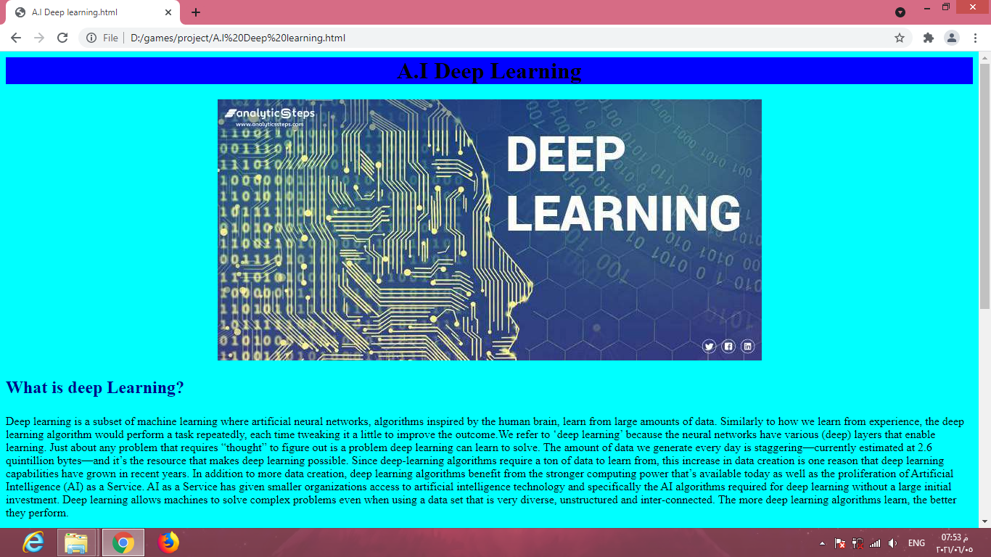2- Deep learning

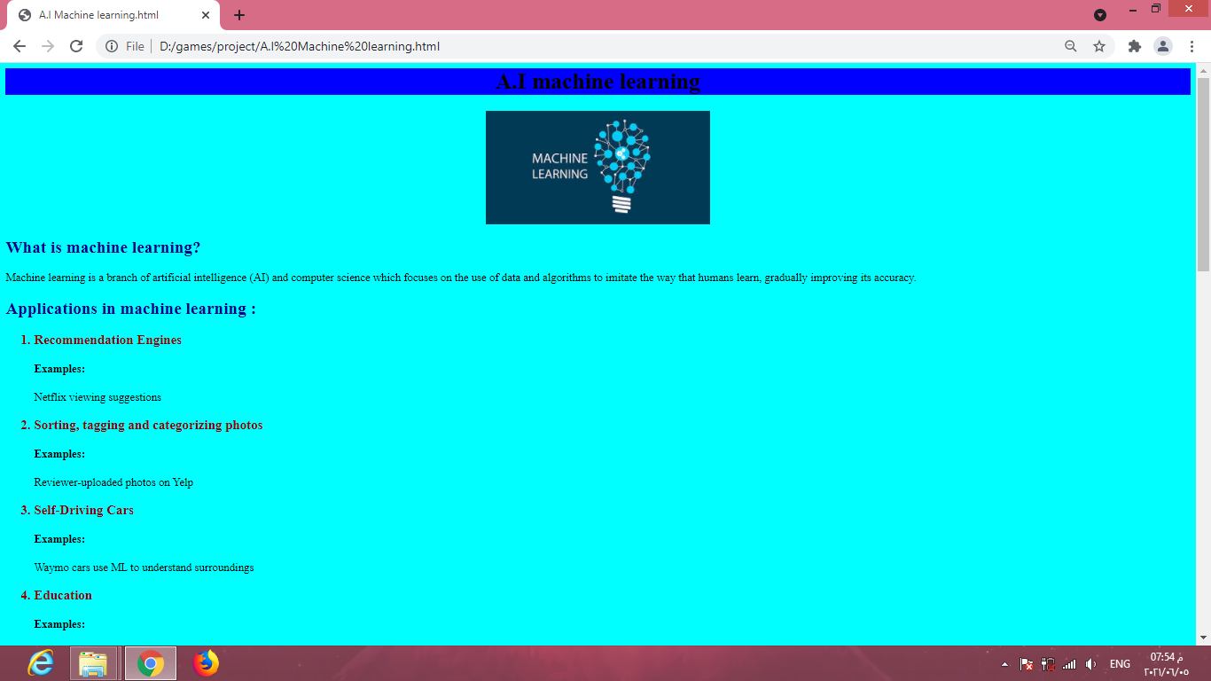3- machine learning

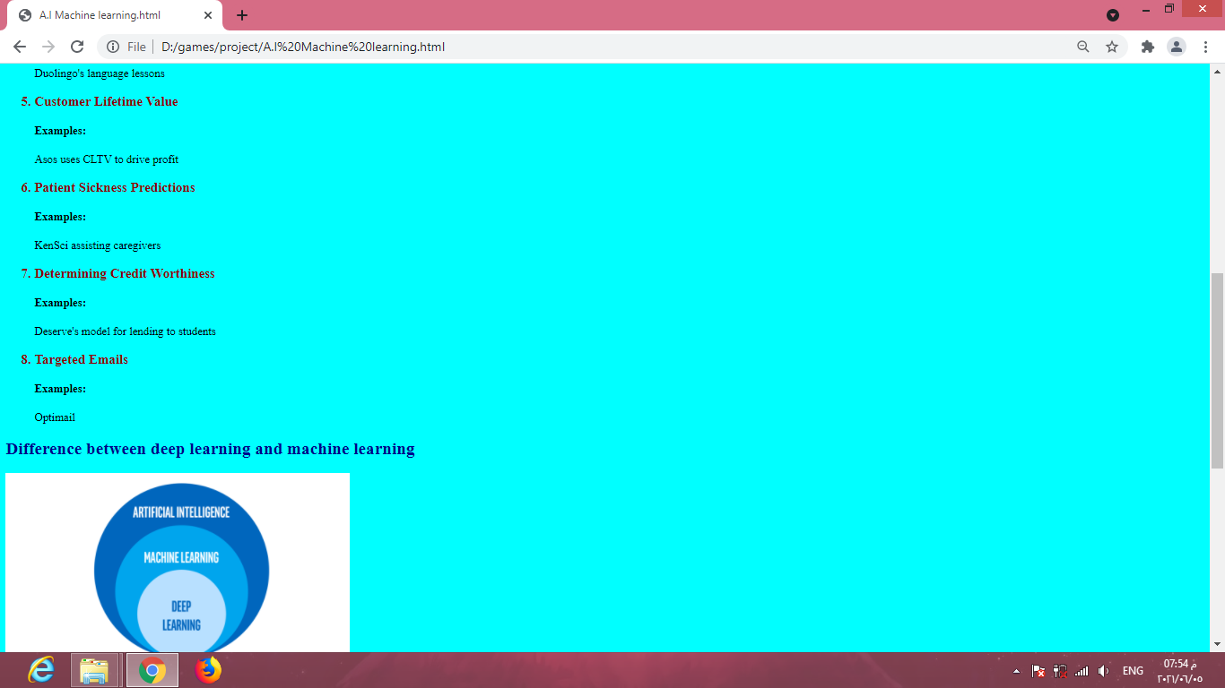

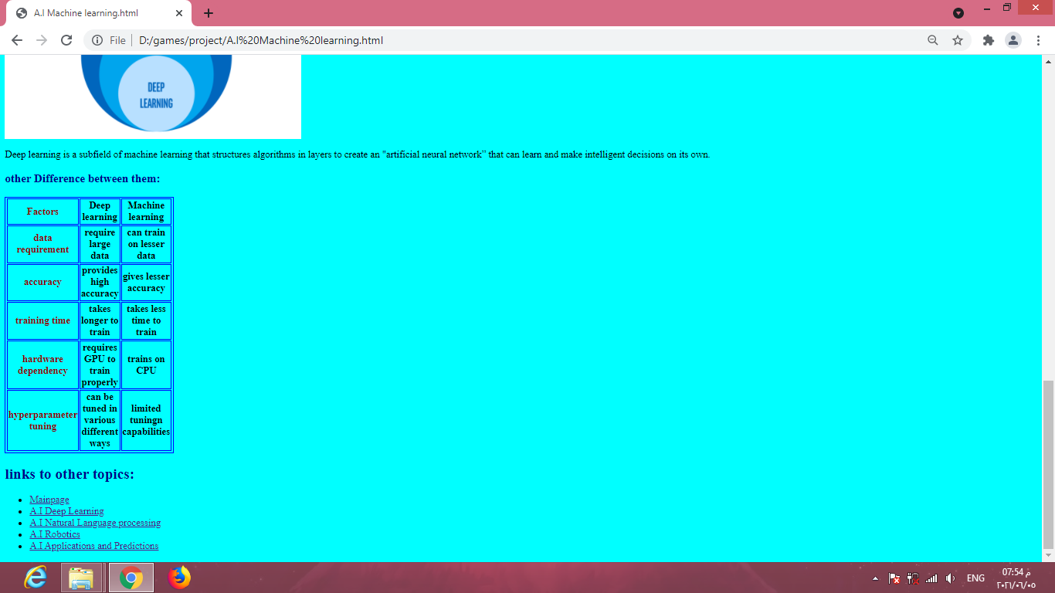

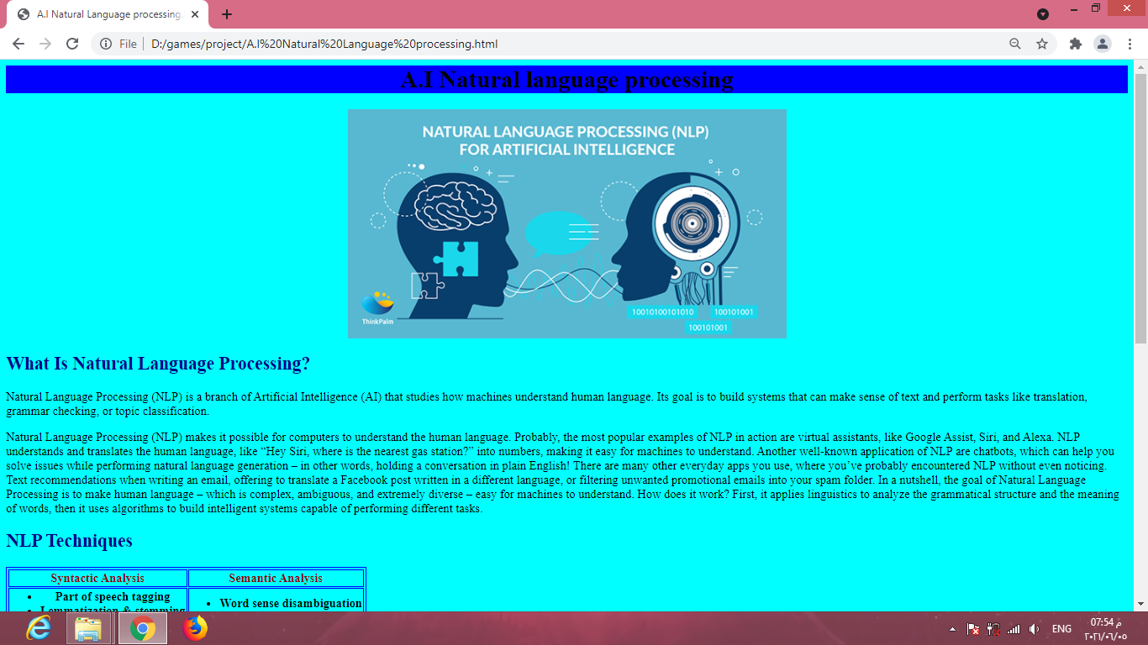4- natural language processing

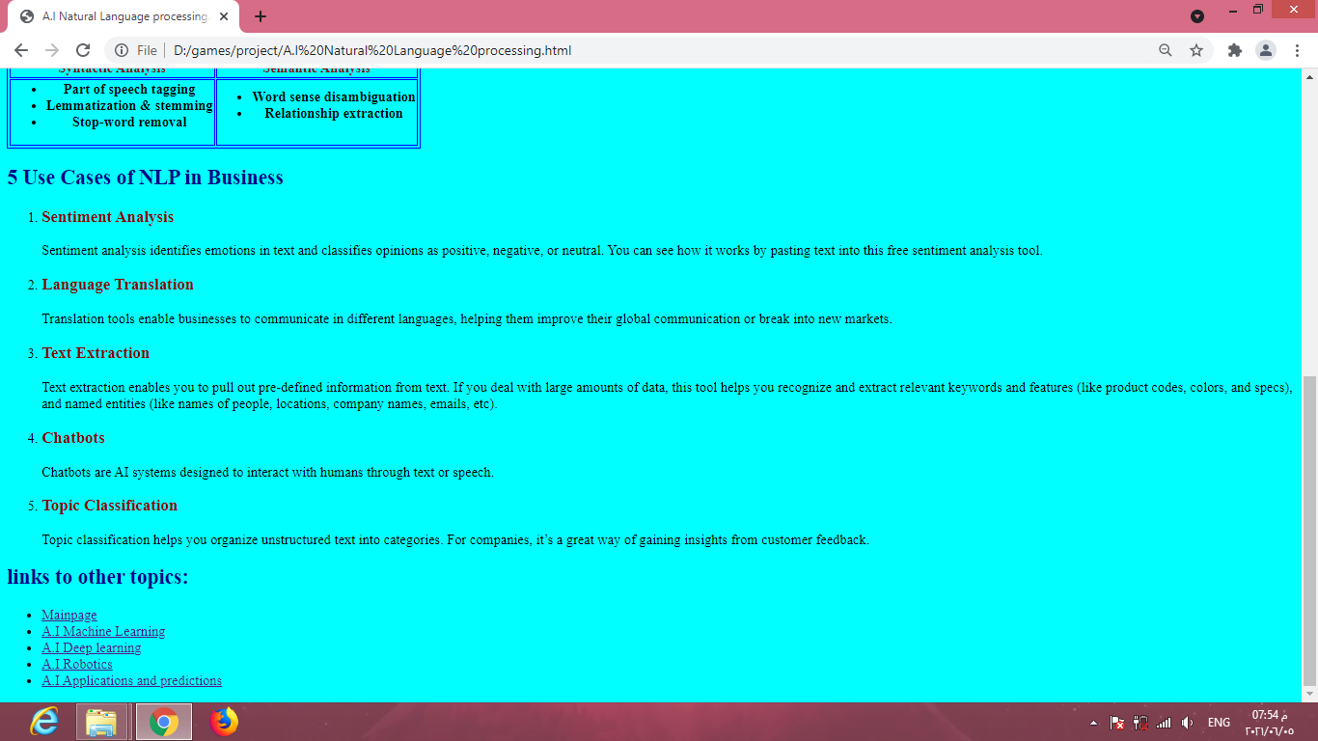

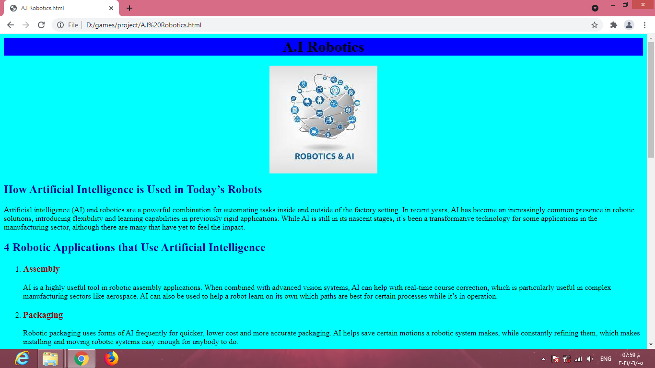5- Robotics

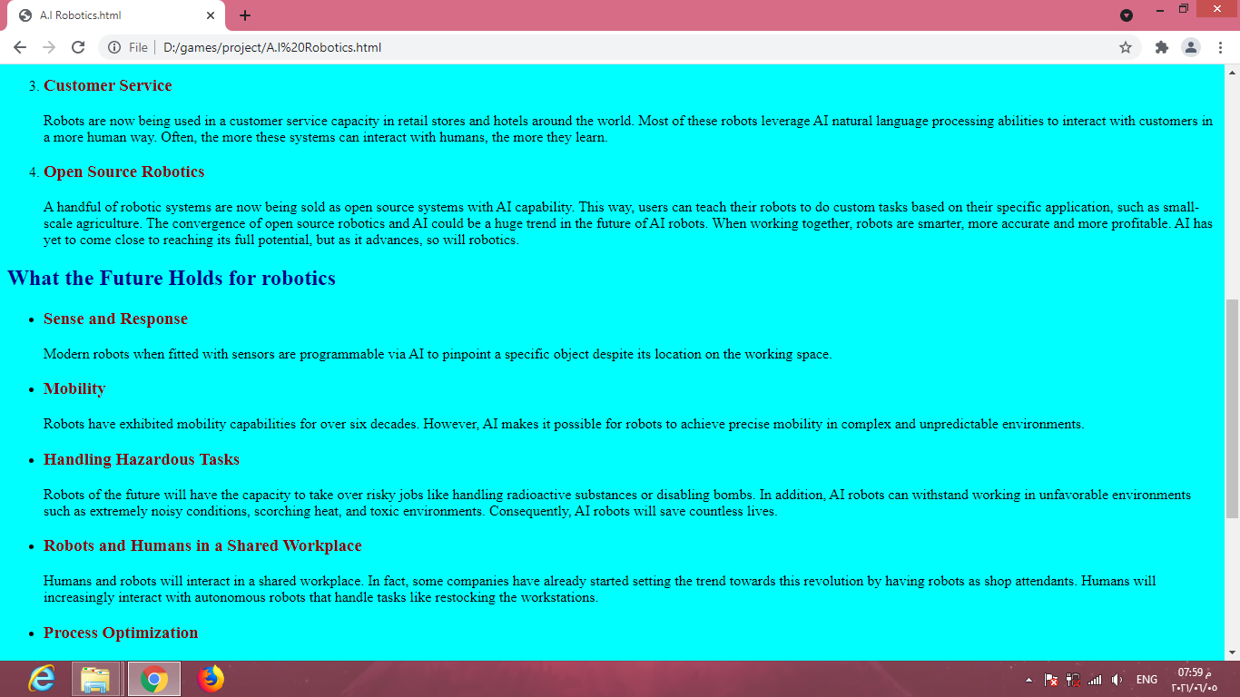

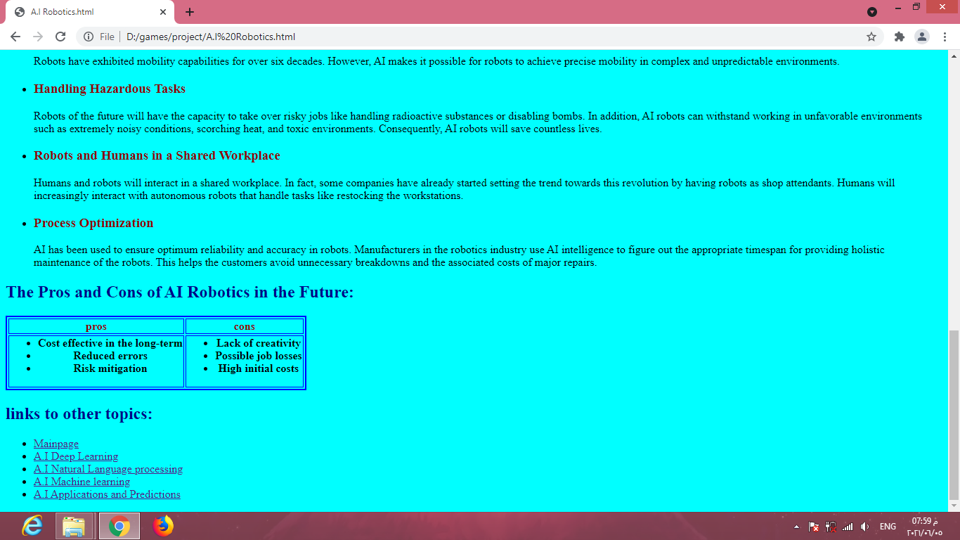

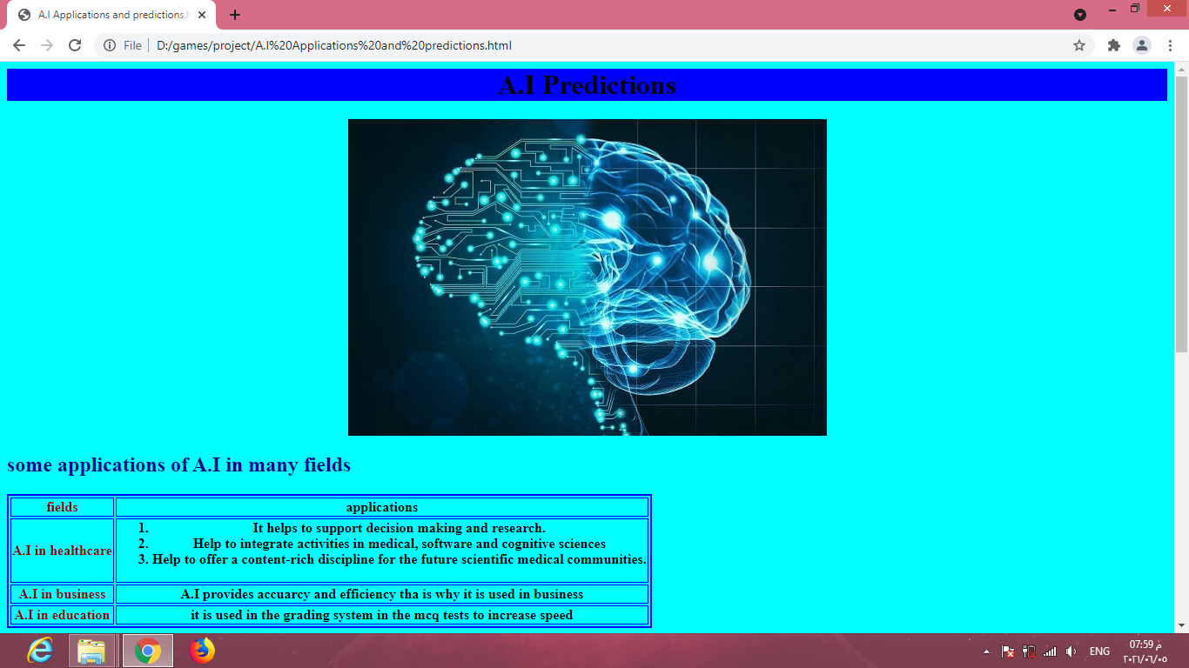6- Applications and Predictions

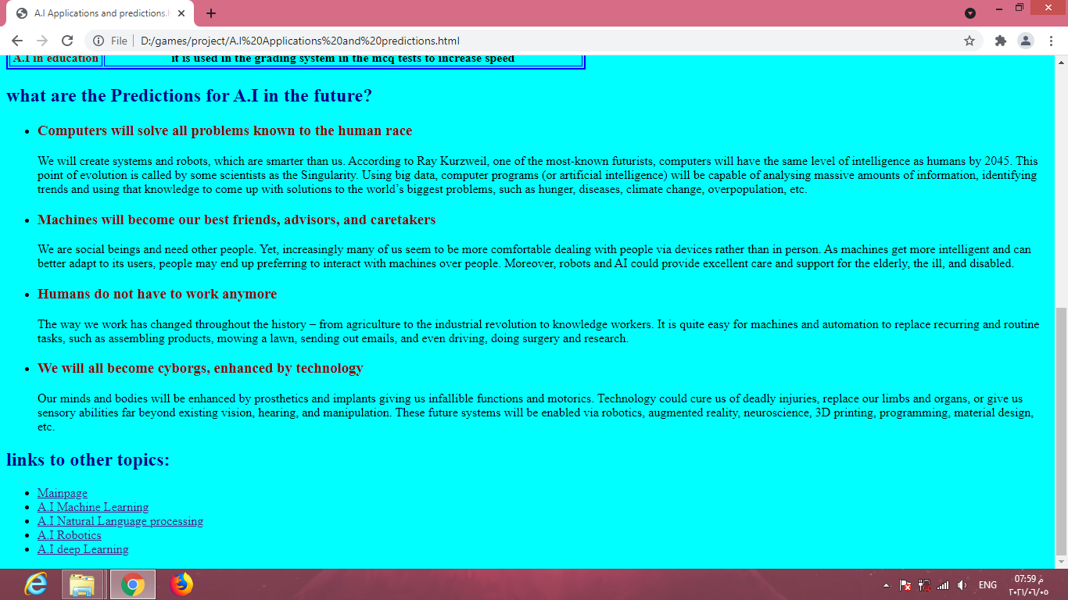

Source codes :

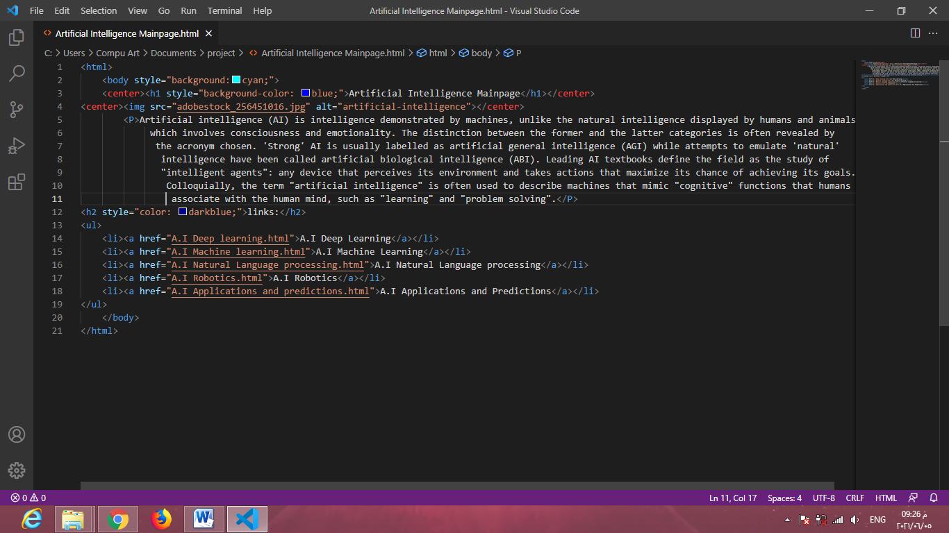1- Mainpage

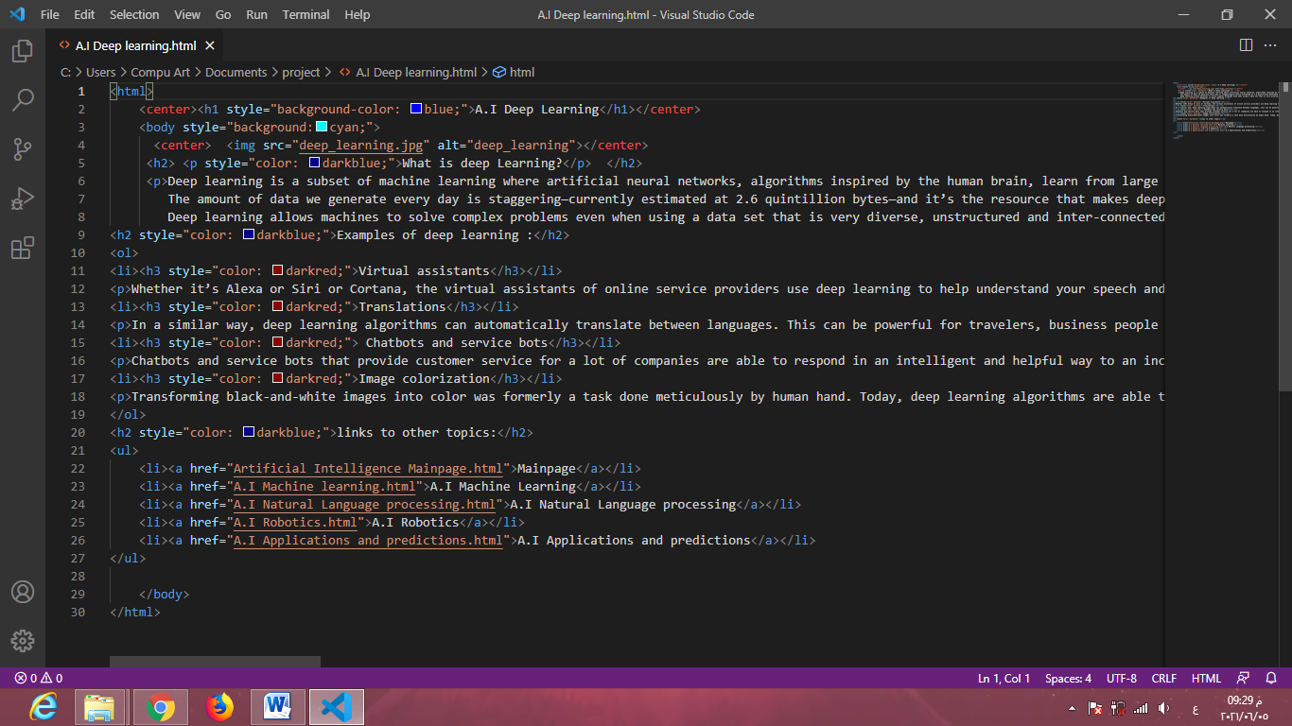2- Deep language

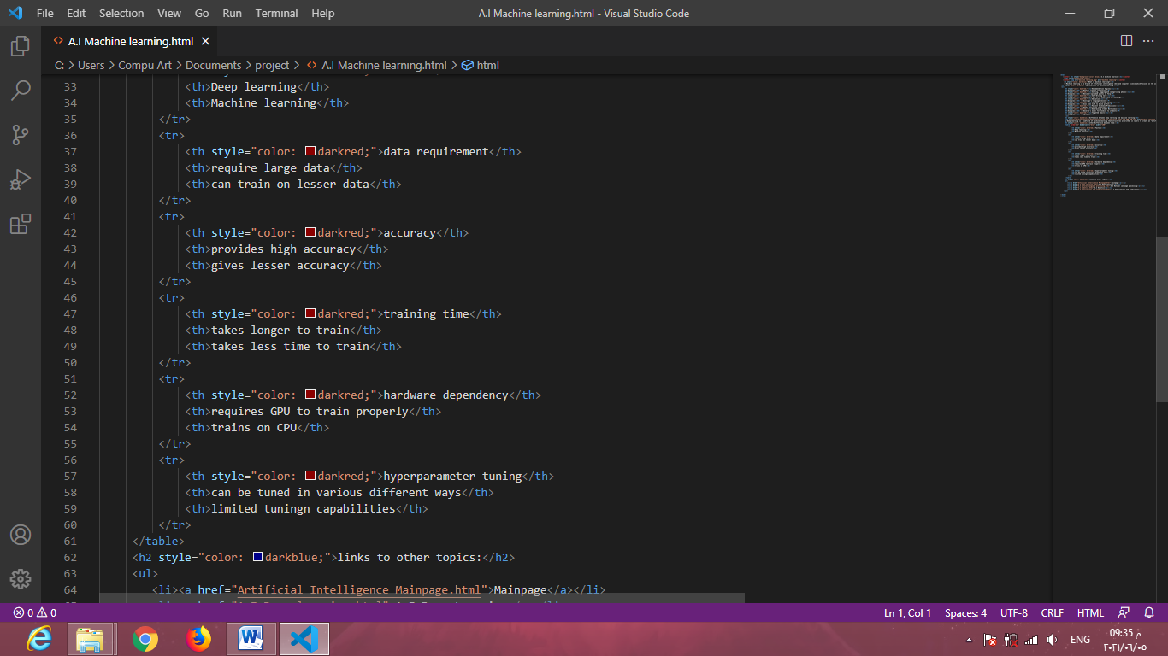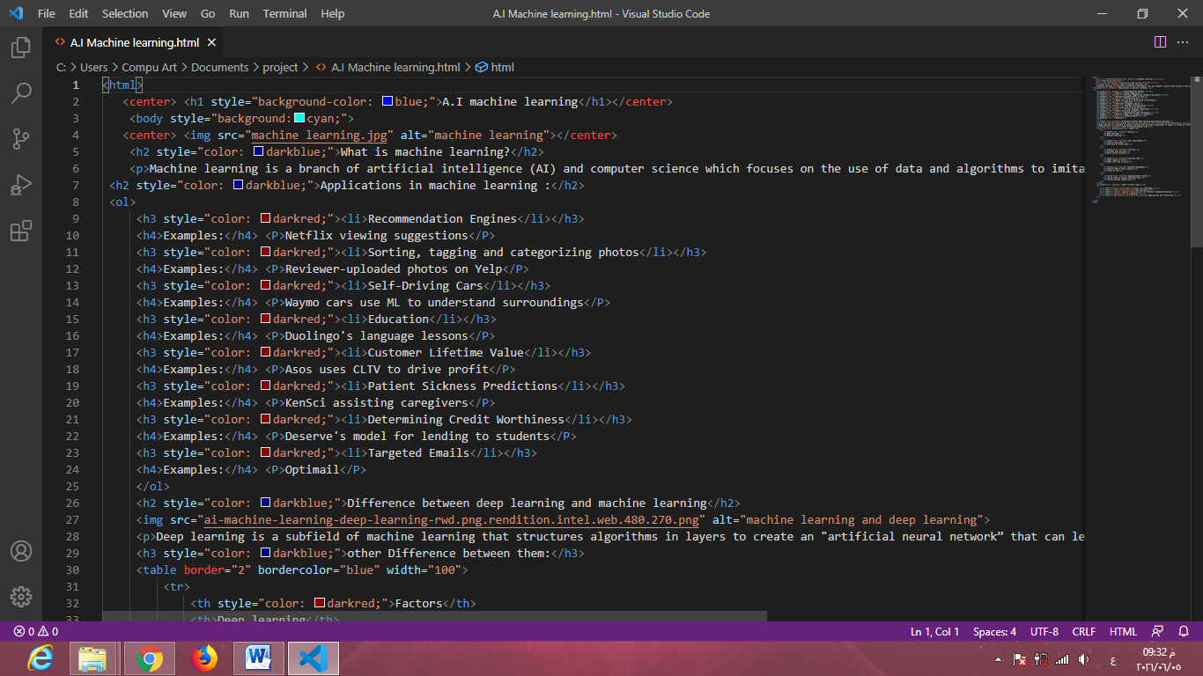3- Machine language

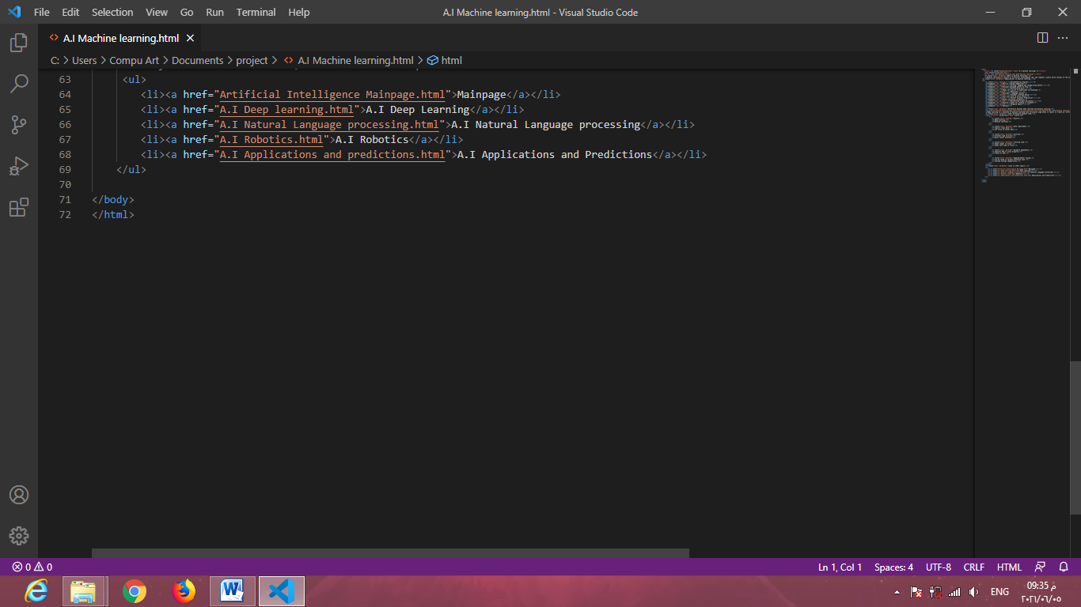

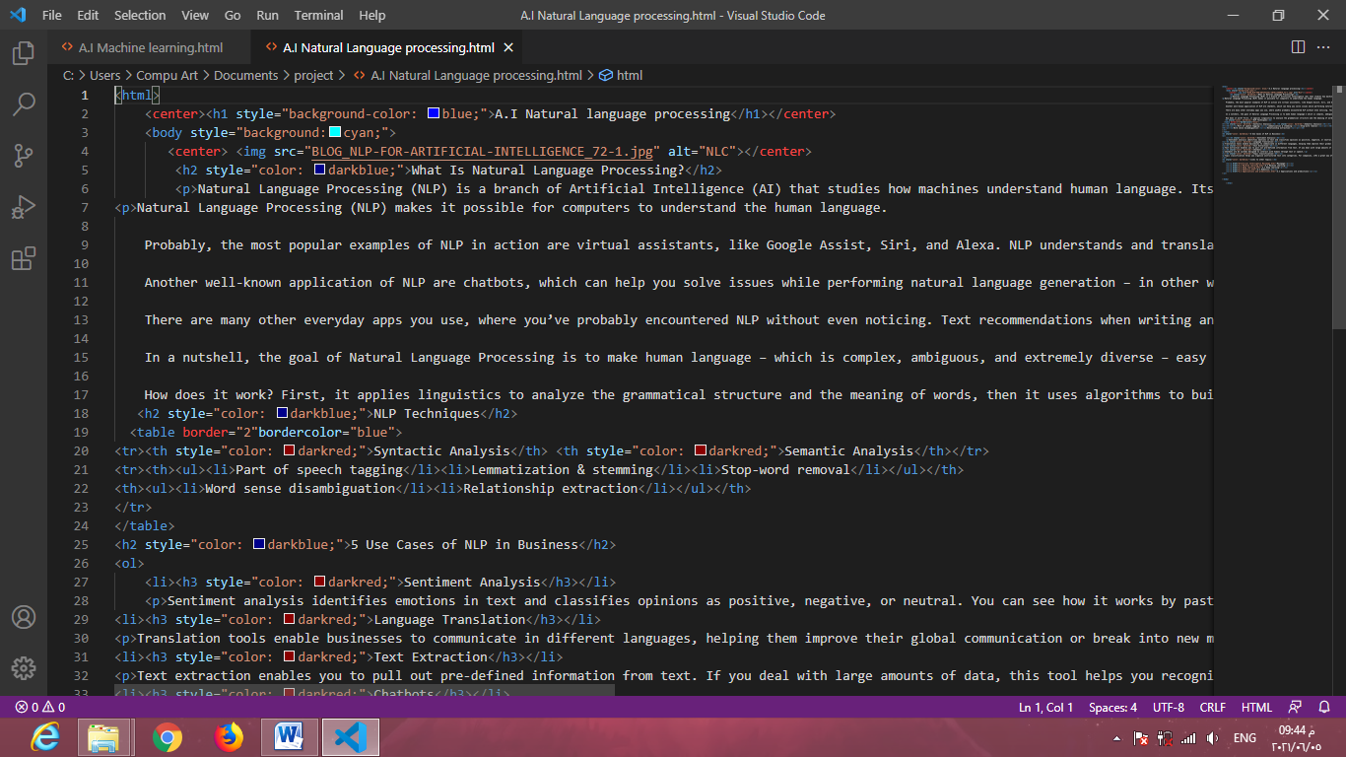4- Natural language processing

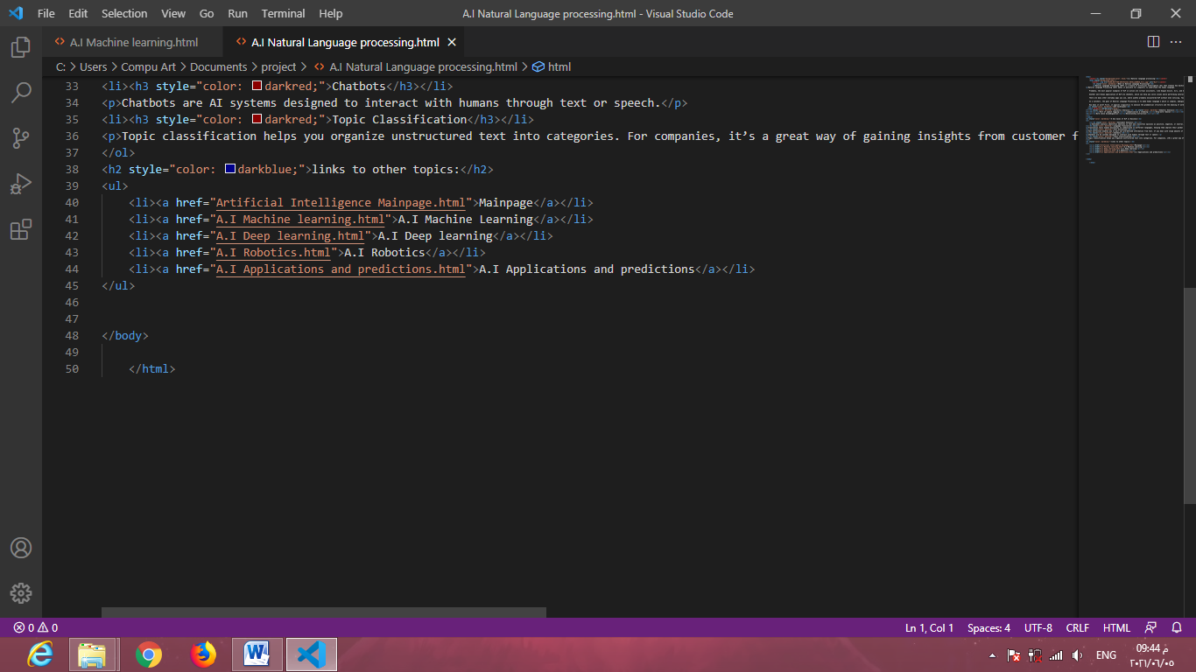

5- Robotics

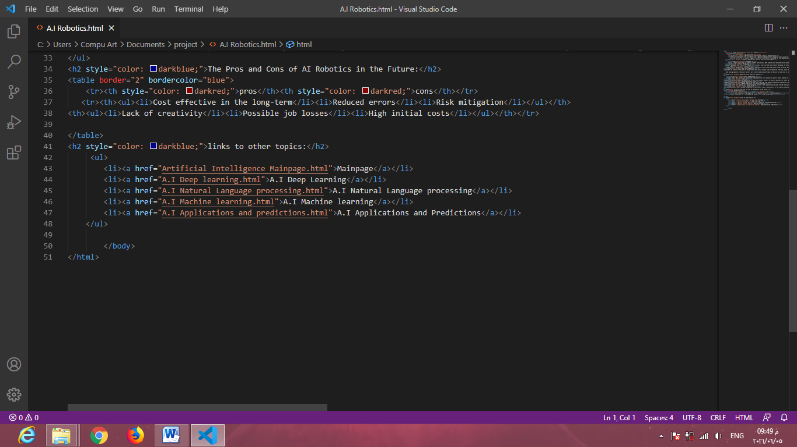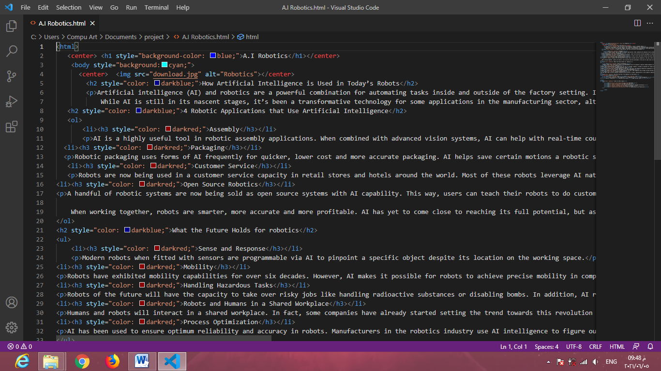

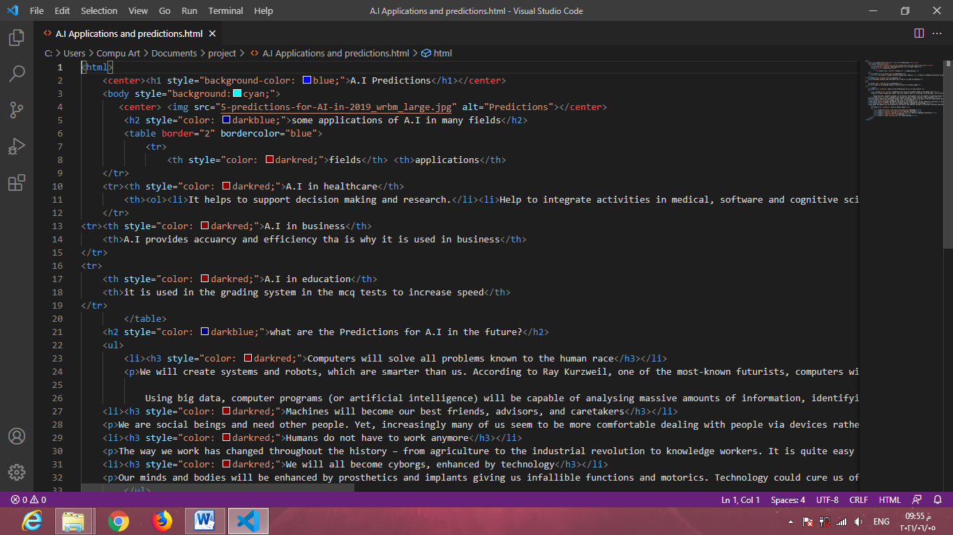6- Applications and Predictions

